Logo Brief Form

Please take your time and answer ALL of the questions. Logo design and branding is a collaborative process and needs your involvement in all stages.

Company A Touch Personalised | Contact Emma Allsop
Address Unit 6, The Barns, Highfield Farm, Mill Lane | Email atouchpersonalised@outlook.com
City, St, Zip Macclesfield SK119BN | Phone# 07545020427
Phone# | Are there other decision makers? Please specify. Simon Allsop
Website address – or desired Domain(s) | Desired domain  Atouchpersonalised.co.uk

Name appearing on the Logo? Yes please

Any tagline/slogan associated with the logo? no

Tell us about Your Company.
Please give us a brief overview of the company, what you do or produce?
Personalized gifts, custom homeware items

Target market
Who are your target audience/typical customer? Include demographics such as: age, gender, education level, income, careers, etc. Try to be as detailed as possible in your descriptions. Profile more than one type if necessary.

What will be your targeted region? (City, State, Country) united kingdom

Theme, Look, Style and Feel
What sort of style do you envision? (e.g. professional, modern and clean, old world, cutting edge, vintage, sporty, futuristic, High end, etc.)

Modern and clean

Adjectives
Please provide some adjectives that describe what you hope to communicate with your logo (e.g. strong, exciting, warm, welcoming, inventive, humorous, feminine, serene, athletic, etc.). Be sure to take a look at the logo examples we provide at the end of this questionnaire.

Ideas, icons, images or symbols
Are the any ideas that you like to use for the logo (or) you are open to ideas?

Do you have any particular images or symbols you associate with your product or company? (e.g. favorite animal or object, like a lion, ship, mountain or tree.)

Colors
What are your color preferences?

Please see below for what each color means:

Blue 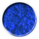
Peace, tranquility, calm, stability, harmony, unity, trust, truth, faith, empathy, ideas, inspiration, friendship, infinity, confidence, conservatism, security, cleanliness, order, loyalty, sky, water, cold, technology, depression.

Red 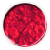
Stimulating, bravery, attention, excitement, speed, fast action, fire, dynamic, heat, eroticism, war, blood, lust, dream careers, vibrant, provoking, exciting, strength, attention.

Green 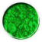
Healing, abundance, safety, fertility, food, hope, resurrection, youth, hope, immortality, health, generosity, envy, quietude, compassion, renewal, moderation, nurturing, diplomacy, calm, misfortune, self-control.

Yellow 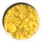
Joy, happiness, logical, optimism, idealism, imagination, hope, sunshine, summer, gold, philosophy, creativity, practical, judge-mental, dishonesty, cowardice, betrayal, jealousy, covetousness, deceit, illness, hazard.

Orange 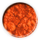
Energy, balance, warmth, enthusiasm, vibrant, expansive, flamboyant, justice, fascination demanding of attention. Red-oranges define sexual passion, desire, aggression. While darker shades of orange have the downside representing deceit, showoff and over-confidence. Lighter shades mean health, happiness, good manners and sophistication.

Purple 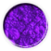
Royalty, spirituality, nobility, selfless, spirituality, ceremony, mysterious, transformation, fantasy, wisdom, enlightenment, artificial, cruelty, arrogance, immaturity, pompous, mourning.

Pink 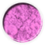
Love, affection, heart, tenderness, friendship, innocence, charm, sweet, gentle, good health, thoughtful, kind, intuitive. The negative traits of pink are physical weakness, immature, low self-worth and willpower, over sensitive and emotional.

White 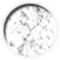
Reverence, purity, simplicity, cleanliness, peace, humility, precision, innocence, youth, birth, winter, snow, good, equality, sterility, marriage (Western cultures), death (Eastern cultures), cold, clinical, sterile, critical.

Black 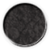
Power, sexuality, sophistication, formality, elegance, wealth, mystery, fear, evil, anonymity, unhappiness, depth, style, dramatic, evil, sadness, remorse, anger, underground, good technical color, mourning, death, control, pessimistic.

Brown 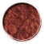
Friendly, warm, strong, practical, sincere, honest, earth, hearth, home, outdoors, reliability, comfort, equality endurance, stability, simplicity, maturity. Some negative qualities are being stingy, passive, materialistic, boring, lacking humor and rough in nature. These traits make brown a favorite among most men.

Gray 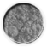
Security, reliability, intelligence, staid, modesty, dignity, formal, maturity, traditional, solid, conservative, practical, old age, sadness, boring.

Gold 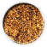
Extrovert, royalty, wisdom, confident, victory, happy-go-lucky, compassionate, sophistication, concentration, masculine energy, attainment, safety, mystic power, classy, generous, self-worth, abundance, mean, envious, fearing success, self-obsessed, fake, lies.

Turquoise 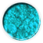
Calm, patience, creative, forgiveness, growth, humanism, emotions, brotherhood, independence, peaceful, healing, serene, joyful, inspiring, innovative, dream, aware, dynamic. Some negative traits are secrecy, imbalance, indecisive, dishonesty.

Silver 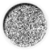
Gentle, kind, meditation, sensitive, dignity, organized, glamour, classy, grace, feminine power, imagination, creativity, high-tech, aging with grace, modernity, compassion. Silver on the negative side is cold, dull, emotionally sensitive, hidden.

Do you have a time frame or deadline to get this?
(If you have a specific deadline, please state why.)

Logo Examples

These examples are a starting point to help illustrate what we mean when we use terms such as corporate, old world, illustrative, etc. There aren’t really clean divisions between these categories. Most of the logos could fall into several categories.

NOTE: Many of the logos depicted below were not created by our company.

Corporate/Professional
Corporate logos are simple, bold and communicate strength. They don't necessarily illustrate what a company does. They are basic trademarks that come to symbolize a company even if they are start as a somewhat arbitrary choice.
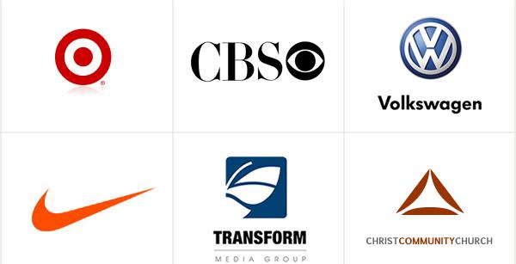

Text Only
Text-only logos are a challenge to keep unique because most fonts are so widely used. But it can provide a nice literary or legal look. Or if you want something artier, a handwritten or arty font can look very unique.
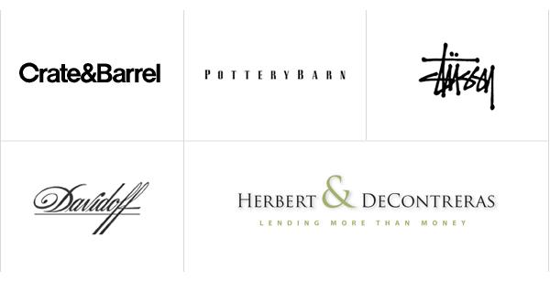

Historical/Seals
These are having a classic rich feel and also have real longevity.
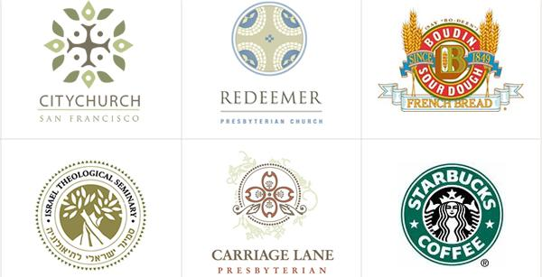

Old World
Fun and beautiful. We're huge fans of old world style.
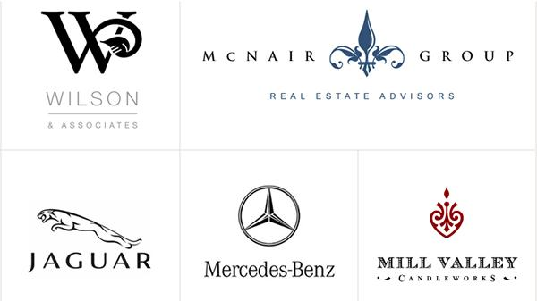

Whimsical
Whimsical logos, when they're based on illustrations take more time and more budget are more unique than any other type of logo.
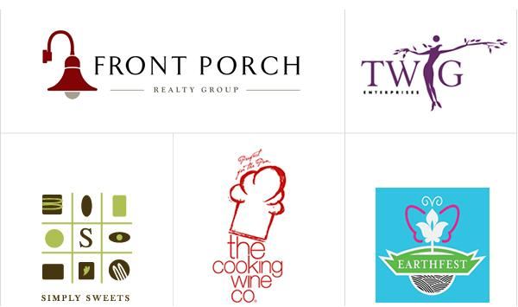

Illustrative
The challenge with illustrative logos is finding a balance between artistic complexity and the simplicity necessary for a memorable brand.

